Part One
An ePortfolio can be a strong tool for self-promotion because it allows me to show actual work instead of just describing my skills. Rather than relying only on a resume, I can include projects like my full-stack application, system diagrams, and enhancements to demonstrate what I can build and how I think through problems. This is especially useful in interviews, where I can walk through my work and explain my decisions, showing both technical ability and communication skills (Simmons & Lumsden, 2016).
To maximize its effectiveness while reducing risk, I need to be intentional about what I include. I should avoid posting sensitive information, such as proprietary code from my workplace or anything tied to client environments such as my medical imaging employer. Instead, I can focus on academic projects or personal work, and when needed, generalize or anonymize details. From my understanding, keeping the portfolio clean, easy to navigate, and well-documented also helps strengthen its marketing value.
There are some downsides to consider. Posting work publicly can expose intellectual property or make it easier for others to reuse ideas without permission. There is also the risk of including incomplete or lower-quality work, which could reflect poorly on my abilities. Because of this, I need to be selective and only showcase projects that represent my best effort and growth (Simmons & Lumsden, 2016).
So far, I have made progress toward several course outcomes, including demonstrating my ability to enhance software artifacts, apply problem-solving strategies, and communicate technical concepts effectively. I have also started organizing my work into a cohesive portfolio structure. However, I still need to strengthen how I integrate all five course outcomes into my final submission and ensure each artifact clearly aligns with those outcomes. Continued refinement and documentation will be key to completing the remaining objectives.

Part Two
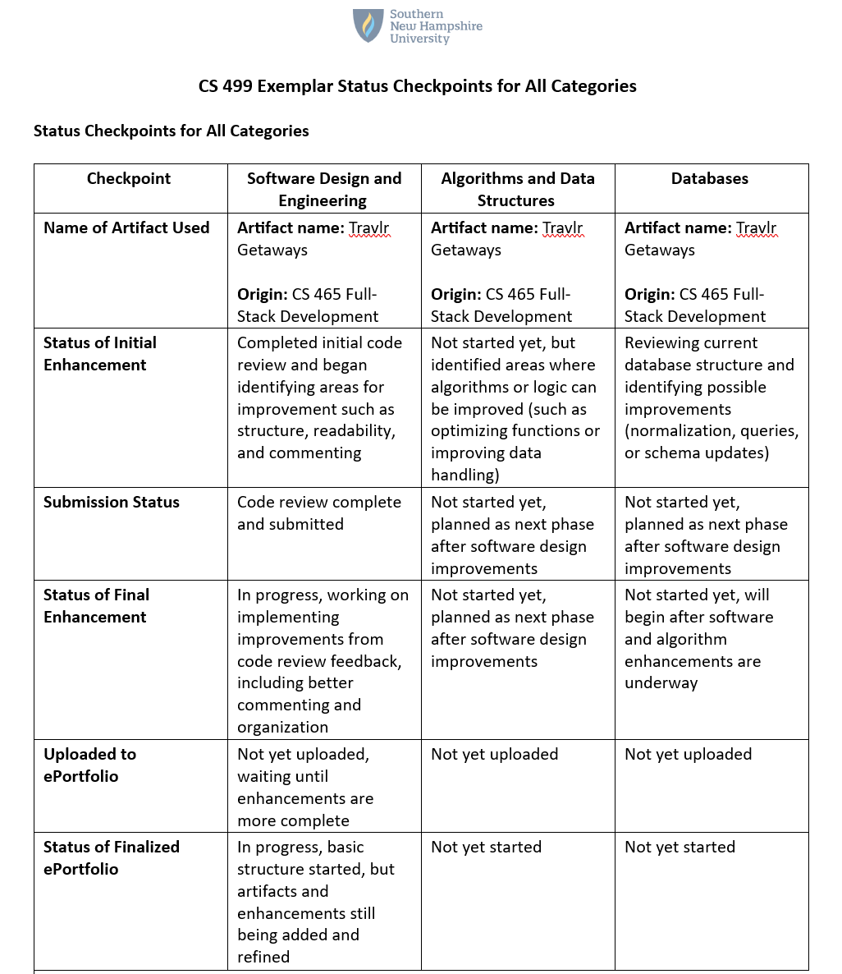

References
Simmons, A., & Lumsden, J. (2016, March). Preparing a Portfolio. Retrieved from Florida State University: https://career.fsu.edu/sites/g/files/upcbnu746/files/Preparing%20a%20Portfolio_0.pdf

